Householder Development – Do I need Planning Permission?

By completing this form you will receive a response confirming whether or not planning permission is required.

Our advice will be based on the information you provide on this form and any additional details submitted. Therefore, the more detailed information you can give about the proposal, the better the advice we can provide on the proposal.

If you do require planning permission you can discuss your proposal with us to find out whether your proposal is acceptable in planning terms through our pre-application service. More information can be found at https://eastcambs.gov.uk/

If you have any queries or require further information on completing this form please e-mail the Planning Team at plservices@eastcambs.gov.uk or call us on 01353 665555.

Please note this is NOT an application for Prior Approval or a Certificate of Lawfulness.

Guidance

All measurements should be in metres.
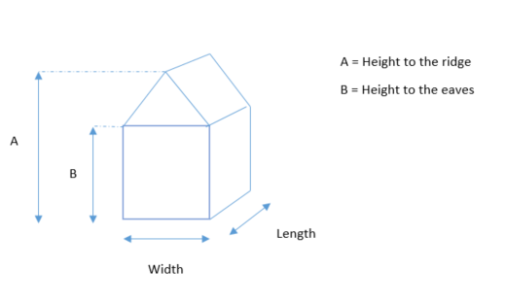
A highway is a road or footpath which the general public has free access over.
Your boundary is the point where your land meets someone else’s land.

Part 1: Person Enquiring (applicant details)

Name:…………………………………………………………..

Address:……………………………………………………………………………………….………………………………………………………………………………………………….
Postcode:………………………….

Daytime telephone number:…………………………………………………..

Email:…………………………………………………………………………………………..

If you are making this enquiry yourself please move on to Part 3.

If you are a planning agent, please complete Part 2.

Part 2: Planning Agent Details

Name:…………………………………………………………..

Address:……………………………………………………………………………………….………………………………………………………………………………………………….
Postcode:………………………….

Daytime telephone number:…………………………………………………..

Email:…………………………………………………………………………………………..

Part 3: Description of Proposed Development

………………………………………………………………………………………………………………………………………………………………………………………………………………………………………………………………………………………………………………………………………

Part 4: Address of Proposed Development (Provide full address & postcode)

Address:……………………………………………………………………………………….………………………………………………………………………………………………….………………………………………………………………………………………………….
Postcode:…………………………………

Part 5: Your home

Is your home:
- Detached
- Semi-detached
- Terraced
- Flat or apartment
- Bungalow

Part 6: Extensions and Conservatories

Please provide the external dimensions (in metres) of the proposed extension.

Type of Extension | Length | Width | Height to ridge | Height to eaves | Height if flat roof

Has the property previously been extended? Yes……......No………...
If yes, please provide dimensions and show on the plan (Part 11)
Length…m Width…m

Does the proposal involve any of the following?
A veranda, balcony or raised platform Yes……….. No………..
Any form of cladding (e.g. pebble dash, render etc.) Yes……….. No………..
Removal of any trees within your ownership Yes……….. No………..

If yes to any of the above, please give details:
……………………………………………………………………………………………………………………………………………………………………………………………………

Please detail materials: ……………………………………………………………………………………………………………………………………………………………………………………………………

Part 7: Outbuildings

Type of Extension/building | Length | Width | Height to ridge | Height to eaves | Height if flat roof

Is the proposed wholly detached from the house? (Please tick) Yes……. No………
If yes, how far is it from the house? Please state in metres………………..
What is the distance from the boundary? Please state in metres…………..

Part 8: Proposed Fencing or Walling

What is the size of the proposed fencing/walling? Please state the height in metres

Length | Height

Will the fencing be located on the boundary? (Please tick) Yes……. No………

Part 9: Porches

Will the proposed porch be to the front of the property? (Please tick) Yes….. No……

What is the external floor area of the porch? (Please state in square metres) ……….

What is the height of the porch at its highest point? (Please state in metres) ………..

Is the porch within 2m of the highway (road or footpath)
outside your property? Yes…….. No……..

Part 10: Dropped Kerbs and Hardstanding

What is the name of the road that the proposed access will connect to?
…………………………………………………………………………………………………..

If you are proposing hardstanding, is this to the front, side or rear of the property?
None proposed……….
Front……………………
Side…………………….
Rear……………………

What is the total area of the hardstanding proposed? (Please state in sqm) …………

Is the hardstanding porous? Yes………. No……....

Is any drainage proposed? Yes………. No……….
If yes, please provide more details
……………………………………………………………………………………………………………………………………………………………………………………………………

Part 11: Other Proposal

Please use this section if your proposal does not fit into any of the categories above.

Description of the proposal (please provide as much detail, including measurements, as possible: ……………………………………………………………………………………………………………………………………………………………………………………………………………………………………………………………………………………………………….

Part 12: Plan of Proposal

This is an example of the type of sketch that would be useful.

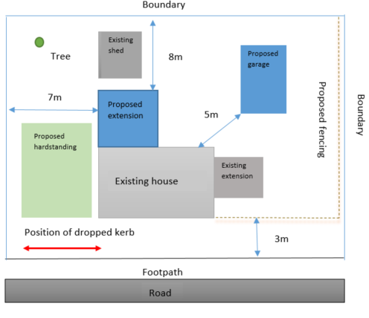

- It need not to be to scale but important dimensions should be marked on.

- All outbuildings and previous extensions should be shown.

- The position of all new works should be shown.

- Show the position of any trees that may be affected.

- The distance from the proposed extension(s) to the boundary should be shown

- The distance from proposed outbuilding(s) should be shown.
Part 12: Plan of Proposal cont.

Don’t forget to show the position of any previous extensions, even those erected prior to your purchase of the property.

Part 13: Signature

I, the undersigned, confirm that I am seeking advice as to whether the proposed development described in this application form requires planning permission.

Signed:…………………………………………………………

Date:…………………………………

Completed Applications together with the fee should be sent to:

Planning Department
East Cambridgeshire District Council
The Grange
Nutholt Lane
Ely
Cambridgeshire
CB7 4EE

Or e-mail: plservices@eastcambs.gov.uk

Privacy Notice
The Council is committed to meeting its data protection obligations and handling your information securely. You should make sure you read and understand the Planning Services privacy notice, which sets out what you need to know about how East Cambridgeshire District Council will use your information in the course of our work as a Local Planning Authority.

Privacy notice | East Cambridgeshire District Council

