Any Parish
Community Emergency Plan

Preparing for and responding to emergencies and community challenges

Plan last updated on: DD/MM/YYYY



How to use this template
This part-completed template is designed for you to fill in the details of your community emergency preparations.

It is based on government best practice guidance and has been adapted for Cambridgeshire with the help of Parish and Town Councils, and the Local Authorities.

Notes on how to create your plan can be found on the Cabinet Office website https://www.gov.uk/government/publications/community-resilience-resources-and-tools

General notes and example text for you to amend are shown in blue.

Text in black (e.g. external contacts or the first meeting agenda) is pre-completed information that you should not need to change.

Important
Documents in the Appendix are those you might need to grab in the event of an emergency.

In addition, some documents in the Appendix contain personal data that should not be made available to the public, i.e. you can publish the main body of the plan on the parish or community website, but not the Appendix.

Your local Council Emergency Planning team will be pleased to help you on request.

Plan distribution list
Issued on
Parish or Community Organisation Chair
Parish or Community Organisation Emergency Co-ordinator
Parish or Community Organisation Deputy Emergency Co-ordinator
City / District / Council Emergency Planning
Voluntary Organisation Chair e.g. Local Flood Warden Group Chair
Parish Council or Community Organisation Website

Consider carefully who should have a copy of the plan. Copies of the plan must be kept securely.

You should make the emergency services aware of your plan and ask if they would like a copy.

If you refer to voluntary organisations in your plan you should make them aware of this and ask if they would like a copy.

Plan amendment list
Date of amendment | Date for next revision | Details of changes made | Changed by
DD/MM/YY | DD/MM/YY | Annex X added | Community Emergency Coordinator
DD/MM/YY | DD/MM/YY | New Community Emergency Team members added | Community Emergency Coordinator
DD/MM/YY | DD/MM/YY | Updated volunteer details | Community Emergency Coordinator

Contents

Plan distribution list
Plan amendment list

Aim and objectives 1
Emergency co-ordinator roles & responsibilities 1
Community emergency volunteer roles 1
Local hazard assessment 2
Local skills and resources 3
Key locations identified for use as places of safety 4
List of community organisations that may be helpful in identifying vulnerable people or communities in an emergency 5
Actions agreed with emergency responders in the event of an evacuation 6
Alternative arrangements for staying in contact if usual communications have been disrupted 6
Activation triggers 8
First steps in an emergency 8
External contacts list 9

Appendix A1
Log sheet A2
Emergency contact list A3
Cascade telephone tree A4
Community Emergency Group first meeting agenda A5
Vulnerable people & assistance they would require A6

Aim and objectives
The aim of this plan is to enhance community resilience. The objectives are to:

- Identify hazards within the community
- Identify resources and key contacts in the community
- Assist in the identification of the vulnerable people and areas within the community

Emergency co-ordinator roles & responsibilities
The role of Emergency Co-ordinator (and their deputy) is fulfilled by volunteer residents who provide a vital link between residents and organisations planning for and responding to an emergency. Their role is to:
- Facilitate the completion and maintenance of the Community Emergency Plan (this plan)
- Call a community meeting during an emergency (if deemed necessary)
- Provide the focal point for the community response to an emergency
- Provide a link between the community and other agencies responding, which may include the Emergency Services and the local council
- Assist the local council and appropriate agencies in emergency preparedness through awareness-raising activities

The Emergency Co-ordinator for [Any Parish] is [Mr Joe Bloggs].
The Deputy Emergency Co-ordinator is [Mrs Pauline Barnes].

Community emergency volunteer roles
Community Emergency Volunteers are residents who provide a link between the Emergency Co-ordinator (or Deputy) and residents in their immediate locality. This could be for one street or a cluster of streets.
Their primary role is to receive information from, and pass it on to, residents in their area.
Some Community Emergency Volunteers may have formal qualifications or training e.g. first aid that may be of assistance until the emergency services arrive.
Other Community Emergency Volunteers may, for example, visit and monitor vulnerable people, help with transport or pass messages on foot when communications are down.

Local hazard assessment
Hazards affecting the community to be listed in the local hazard assessment table could include:
- Severe weather – snow, ice, gales, heat wave
- Total or partial loss of gas, electricity and water supplies
- Tidal, river or surface water flooding
- Loss of road access
- Anything specific to your community that would test your resources and require a community response.
One worked example is given below.

Hazard | Impact on community/Location | What can the Community Emergency Group do to prepare / assist?
Severe Weather -  Heavy Snow / Freezing Conditions | - Possible loss of road access –Mill Road, Anytown  - If cut off, possible food or heating fuel shortages  - Increased potential for slips and falls – Hill by church, on Mill Road  - Limits movement of some vulnerable people – Sheltered Housing complex. | - Monitor weather forecasts & take precautions when required  - Ensure water supplies to empty or unheated premises are adequately protected from freezing or shut off  - Check and support vulnerable people  - Report utility failures to council & relevant utility organisations  - Report frozen or burst water mains  - Check location of grit bins (for use on roads, not pavements)  - Encourage residents to clear snow when safe from pavements outside their properties. Consider clearing other pavements (special salt bins may be provided for this)

Local skills and resources
[Consider what tools and machinery might be needed in an emergency - there may be people in your community who are qualified, capable and willing to operate them. Use local knowledge and information from community groups. You might want to use the resident questionnaire in Supporting Information to aid the completion of the Community Emergency Plan. The Emergency Planner from your local council will advise you.]

Skill/Resource | Who? | Contact details | Location | When might be unavailable?
Trained first aider | Andy Ford | 01700 5668xx | 17 Brookside Street | Can usually leave work within one hour
4x4 owner/driver | Bob North | 01600 5688xx | Garages to rear of High Street | Tuesday mornings (already volunteers)
Water/food supplies | Village Shop | 01400 5508xx | 5 High Street | Shop closed on Weds but can call owner

Key locations identified for use as places of safety
[Identified with the Local Authority as safe places of assembly for evacuation or temporary accommodation e.g. Community Hall, Scout Hut.]

Building | Location | Potential use in an emergency | Contact details of key holder
Example: Catley Sports Centre | 5 Field Lane | Local Authority Designated Rest Centre | Jane Richards – Caretaker  07749 8655xx
Example: Church Hall | 8 Church Square | Evacuation assembly point | Colin Wentworth – Warden  07749 8557xx

[You might want to include a map showing key buildings and features e.g. rest centre, evacuation assembly point, schools, care homes etc.]

List of community organisations that may be helpful in identifying vulnerable people or communities in an emergency
[Note: Use this space to record details of your local voluntary and faith sector contacts e.g. local church, first aid group, Women’s Institute etc.]

Organisation | Name and role of contact | Phone number
Anytime Care | Duty contact | 07810 555xxxx

Actions agreed with emergency responders in the event of an evacuation
[Note: Use this space to record details of the actions you can take to help emergency responders (e.g. police, local authority) if an evacuation is necessary in your community.]

- Help police/local authority with the identification of vulnerable people (who should receive the earliest possible warnings and instructions).

- Help police/local authority warn and inform the public e.g. if requested, assist with communicating the message to evacuate or door knocking.

- Other points specific to your community.

[Note: “Vulnerable people” includes but is not limited to: the very young and old, those who are immobile, disabled, have dementia, have a sensory impairment, have recently had an operation, are dependent on prescription medication (which they would need if evacuated, for example), have language issues, limited access to transport, are visitors to the area or are transient.]

Alternative arrangements for staying in contact if usual communications have been disrupted
[Note: It would be helpful to responding services to have a means to communicate to a significant amount of the population as quickly as possible to help warn and inform the public. Please consider how you could help with this. Also consider communications between the Emergency Co-ordinator, Community Emergency Volunteers and the community. Consider and record the network coverage of mobile phone providers in your area.]

Communication Type | Name of contact | Location
Message runners | Allocated on the day
Radio Enthusiast | Bob Radiohead | 1 Mercedes Close
Information boards at [location]

Activation triggers
[Use this space to record details of how your plan will be activated. You should include details of how the plan will be activated as a result of a call from the emergency services, and also how your community will decide to activate the plan yourselves, if the emergency services are unavailable.]

- When we get a flood warning

- When contacted by Emergency Services

- When contacted by the Emergency Planning Team

First steps in an emergency
 | Instructions | Tick
1 | Call 999 (unless already alerted) to ensure the emergency services are aware of the emergency. Follow any advice given.
2 | Ensure you are in no immediate danger.
3 | Review activation triggers and decide whether to activate this plan.  Use the log sheet in the Appendix to record decisions made, who you spoke to and what you said.
4 | Contact other members of the community that need to be alerted:  - The Parish/Town Council via the Clerk  - Members of the Emergency Group  - Those specifically under threat  Contact initially may be to inform them of the emergency or inform them of current Emergency Service advice regarding any action to be taken.
5 | Determine if a Community Emergency Meeting is necessary.  If one is needed:  - Check the meeting venue is safe and people can get there safely  - Contact the key holder for the building  - Contact Community Emergency Volunteers via the call cascade, if not already done  - Tell the community there will be a meeting (if appropriate)  - Advise the District / City / Town Council you are holding a Community Emergency Meeting  - Take a copy of the First Agenda to the meeting.
6
7

Do not put yourself or others at risk to fulfill these tasks

External contacts list
Service / Role | Additional info | Telephone number | Website / email
Emergency Services |  | 999
Police HQ | For non-999 calls | 101 | www.cambs.police.gov.uk
Fire Service HQ | For non-999 calls | 01480 444500 | www.cambsfire.gov.uk
Environment Agency | Floodline and Flood Warnings | 0345 988 1188 | www.environment-agency.gov.uk
Cambridgeshire County Council | Customer Service Centre number | 0345 0455200 | www.cambridgeshire.gov.uk
East Cambridgeshire District Council | Customer Services | 01353 665555 | www.eastcambs.gov.uk
East Cambridgeshire District Council | Emergency Planning | 01353 616249 | emergencyplanning@eastcambs.gov.uk
Water - Anglian Water | Reporting Leaks | 0800 771881 | www.anglianwater.co.uk
Water - Anglian Water | Water & Sewage Queries | 03457 145145 | www.anglianwater.co.uk

List continues overleaf

External contacts list - continued
Service / Role | Additional info | Telephone number | Website / email
Electricity - UK Power Networks | Electricity cables down or causing significant risk | 999 | www.ukpowernetworks.co.uk
Electricity - UK Power Networks | Supply interruption, 24hr fault line | 105 or 0800 3163105 | www.ukpowernetworks.co.uk
Gas - National Grid | 24hr emergency number for gas safety | 0800 111 999 | www.nationalgrid.com/safety-and-emergencies
Telephones British Telecom | BT faults and all line faults | 151 | www.bt.com
Medical NHS | Urgent medical problem but unsure what to do | 111 | 111.nhs.uk
Local doctors’ surgery
Local hospital

Appendix
- Log sheet
- Emergency contact list
- Cascade Telephone Tree
- Community Emergency Group first meeting agenda
- Vulnerable people and assistance they may require

Log sheet
[It is essential to keep a log of the actions you have taken during an emergency.]

Date | Time | Information / Decisions / Actions | Initials

Emergency contact list
Name: Joe Bloggs
Title: Emergency Co-ordinator
24hr telephone contact: 07760 7785xx
Email: xx@xx.xx

Address: 2 Rookdale Road

Name
Title:
24hr telephone contact:

Email:
Address:

Name
Title:
24hr telephone contact:

Email:
Address:

Cascade telephone tree
In the event of an emergency, the cascade telephone system will be implemented as quickly as possible. If the landline telephone system is unavailable, mobiles will be used. If both landlines and mobiles are unavailable, local area representatives will be contacted on foot.

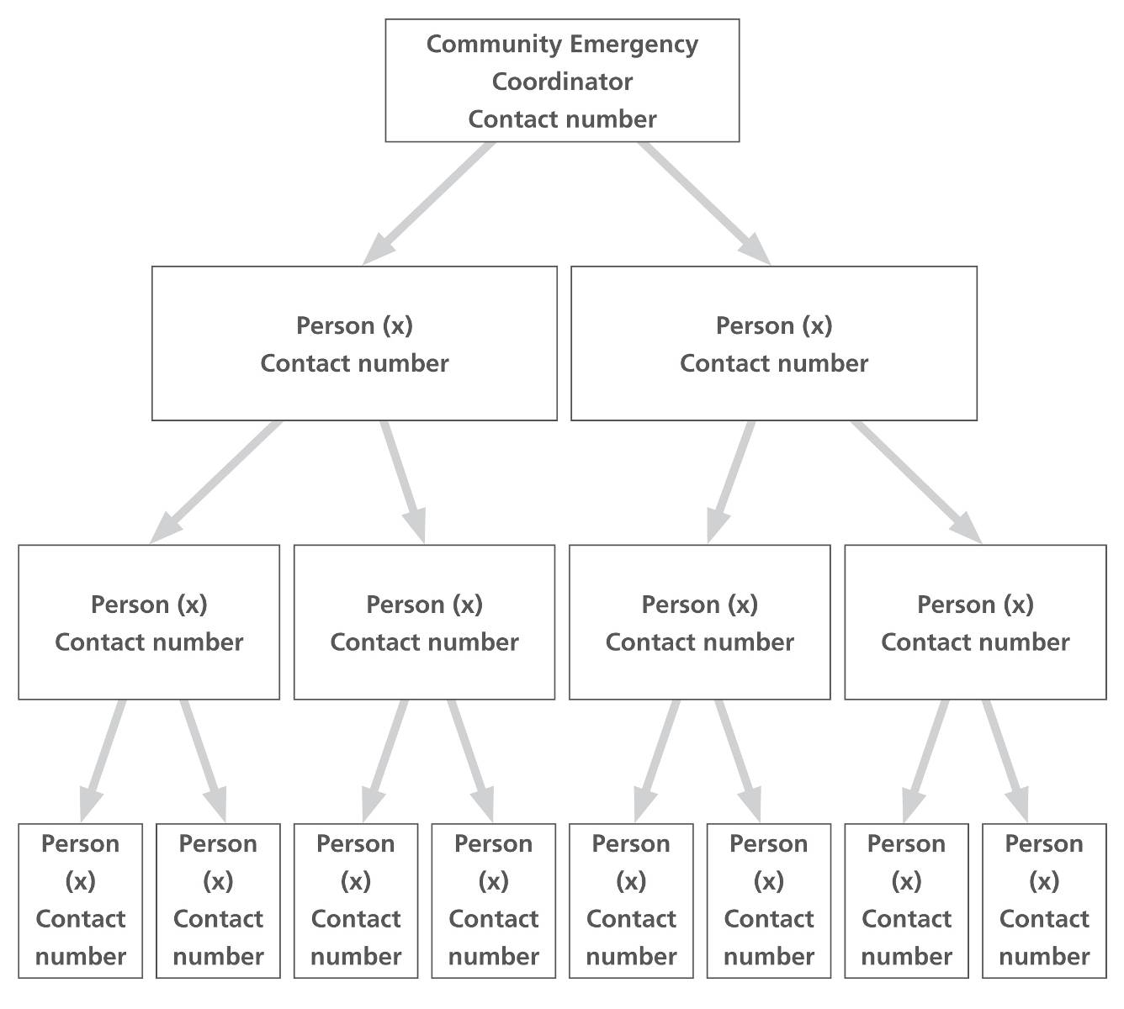
Community Emergency Co-ordinator
Contact number

Community Emergency Group first meeting agenda
Date & time:
Meeting venue:
Attendees: (Numbers. Identify key individuals)

1. Briefing on the current situation. Issues to consider:
- Location
- Type of incident
- Numbers of people involved and their condition
- Threats to life
- Current and potential hazards
- Access to the scene
- Condition of utilities (electricity, gas, water, sewerage, telephones)
- Availability of fuel oil, coal etc
- Vulnerable people (e.g. very young/old, immobile, disabled, dementia, sensory impairment, recent operation, dependent on prescription medication, language issues, visiting the area, transient)

2. Immediate actions and resources to aid the response to the emergency Issues to consider:
- Assistance that can be given to the emergency services / establishing contact with the emergency services if not already done
- The actions that can safely be taken - consider health and safety of all responders
- How the actions are to be co-ordinated within the emergency group and with emergency services
- Communication with the emergency services, Community Emergency Volunteers and the community
- Vulnerable people - welfare checks, language issues

3. Actions and resources required in the longer term to aid community recovery e.g. Advice, guidance, physical assistance

4. Who is going to take the lead for the agreed actions?

5. Any other issues?
6. Time, date and venue of next meeting

Record key points on the log sheet

Vulnerable people & assistance they may require

Name | Contact details | Location | Type of assistance required
The Swallows | 0xxxxx | Willows Lane | Transport & Care

[Note: You do not have to complete this table. You might consider the “List of community organisations that may be helpful in identifying vulnerable people or communities in an emergency” is sufficient to identify most vulnerable people.
If you would like to compile this more comprehensive list, use local knowledge and information from community groups and care providers as well as that gained from the resident questionnaire in the Supporting Information document to help you complete it.
Data in this table will have to be reviewed annually.]
This page is intentionally blank

